**PIZZA SALES SQL SQUERIES**

**A.KPI’s**

**1. Total Revenue**

SELECT SUM(total_price) As Total_Revenue from pizza_sales;

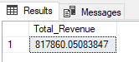

**2. Average Order Value**

SELECT SUM(total_price) / COUNT(DISTINCT order_id) as Average_Order_Value from pizza_sales;

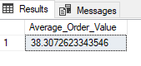

**3. Total Pizzas Sold**

SELECT SUM(quantity) As Total_Pizza_Sold from pizza_sales

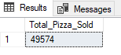

**4. Total Orders**

SELECT COUNT(DISTINCT order_id) As Total_Orders from pizza_sales

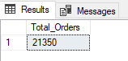

**5. Average Pizzas Per Order**

SELECT CAST(CAST(SUM(quantity) As DECIMAL(10,2)) /

CAST(COUNT(DISTINCT order_id) AS DECIMAL(10,2)) AS DECIMAL(10,2))as Average_Pizza_Order from pizza_sales

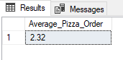

**B. Daily Trend for Total Orders**

SELECT DATENAME(DW,order_date) as order_day, COUNT(DISTINCT order_id) as Total_Orders

from pizza_sales

GROUP BY DATENAME(DW,order_date)

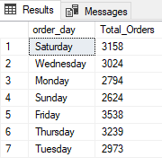

**C. Hourly Trend for Orders**

SELECT DATEPART(HOUR,order_time) As order_hours, COUNT(DISTINCT order_id) as Total_orders

from pizza_sales

GROUP BY DATEPART(HOUR,order_time)

ORDER BY DATEPART(HOUR,order_time)

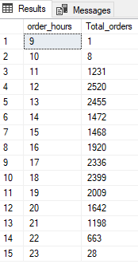

**D. % of Sales by Pizza Size**

select pizza_size,sum(total_price) as total_price, CAST(((SUM(total_price) * 100) /

(select sum(total_price) from pizza_sales)) as DECIMAL(10,2)) as percentage

from pizza_sales

group by pizza_size

**Output:**

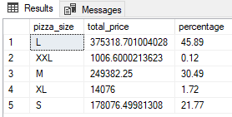

**E. % of Sales by Pizza Category**

SELECT pizza_category, CAST(SUM(total_price) AS DECIMAL(10,2)) as total_revenue,

CAST(SUM(total_price) * 100 / (SELECT SUM(total_price) from pizza_sales) AS DECIMAL(10,2)) AS PCT

FROM pizza_sales

GROUP BY pizza_category

**Output:**

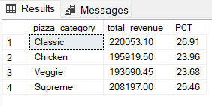

**F. Total Pizzas Sold by Pizza Category**

SELECT pizza_category, SUM(quantity) as Total_Quantity_Sold

FROM pizza_sales

WHERE MONTH(order_date) = 2

GROUP BY pizza_category

ORDER BY Total_Quantity_Sold DESC

**Output:**

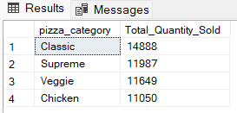

**G. Top 5 Best Sellers by Total Pizzas Sold**

select top 5 pizza_name, sum(quantity) as total_pizzas_sold

from pizza_sales

group by pizza_name

order by total_pizzas_sold desc

**Output:**

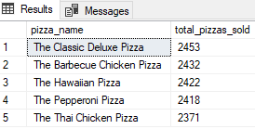

**H. Bottom 5 Best Sellers by Total Pizzas Sold**

select top 5 pizza_name, sum(quantity) as total_pizzas_sold

from pizza_sales

group by pizza_name

order by total_pizzas_sold

**Output:**

